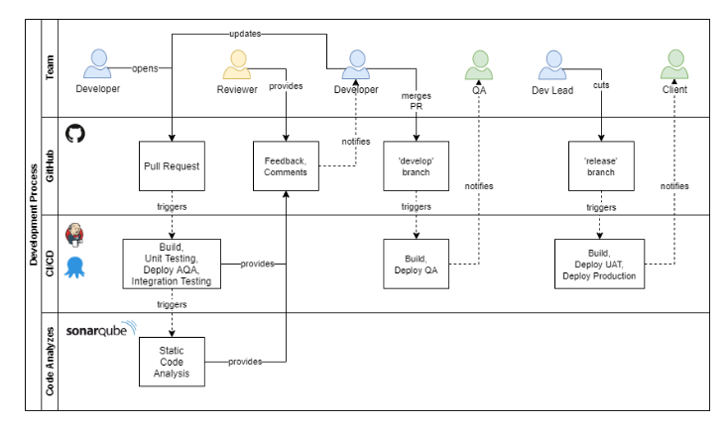

1. Testing can be separated into 4 different stages — DEV, SIT(qa), UAT and PROD.

2. DEV is a test carried out by the software developers who made the functions.

3. SIT(qa) is a test for the integration test where your changes will be tested along with others.

4. UAT is carried out by client and probably a small group of registered tester.

5. PROD is the stage where app has been publicly released.

Remember our chef example.

**Build**:

build refers to the process that converts files and other assets under the developers’ responsibility into a software product in its final or consumable form. The build may include:

• compiling source files

• packaging compiled files into compressed formats (such as jar, zip)

• producing installers

The build is automated when these steps are repeatable, require no direct human intervention, and can be performed at any time with no information other than what is stored in the source code control repository.

**Deployment**:

Placing your software to testing and production environments.